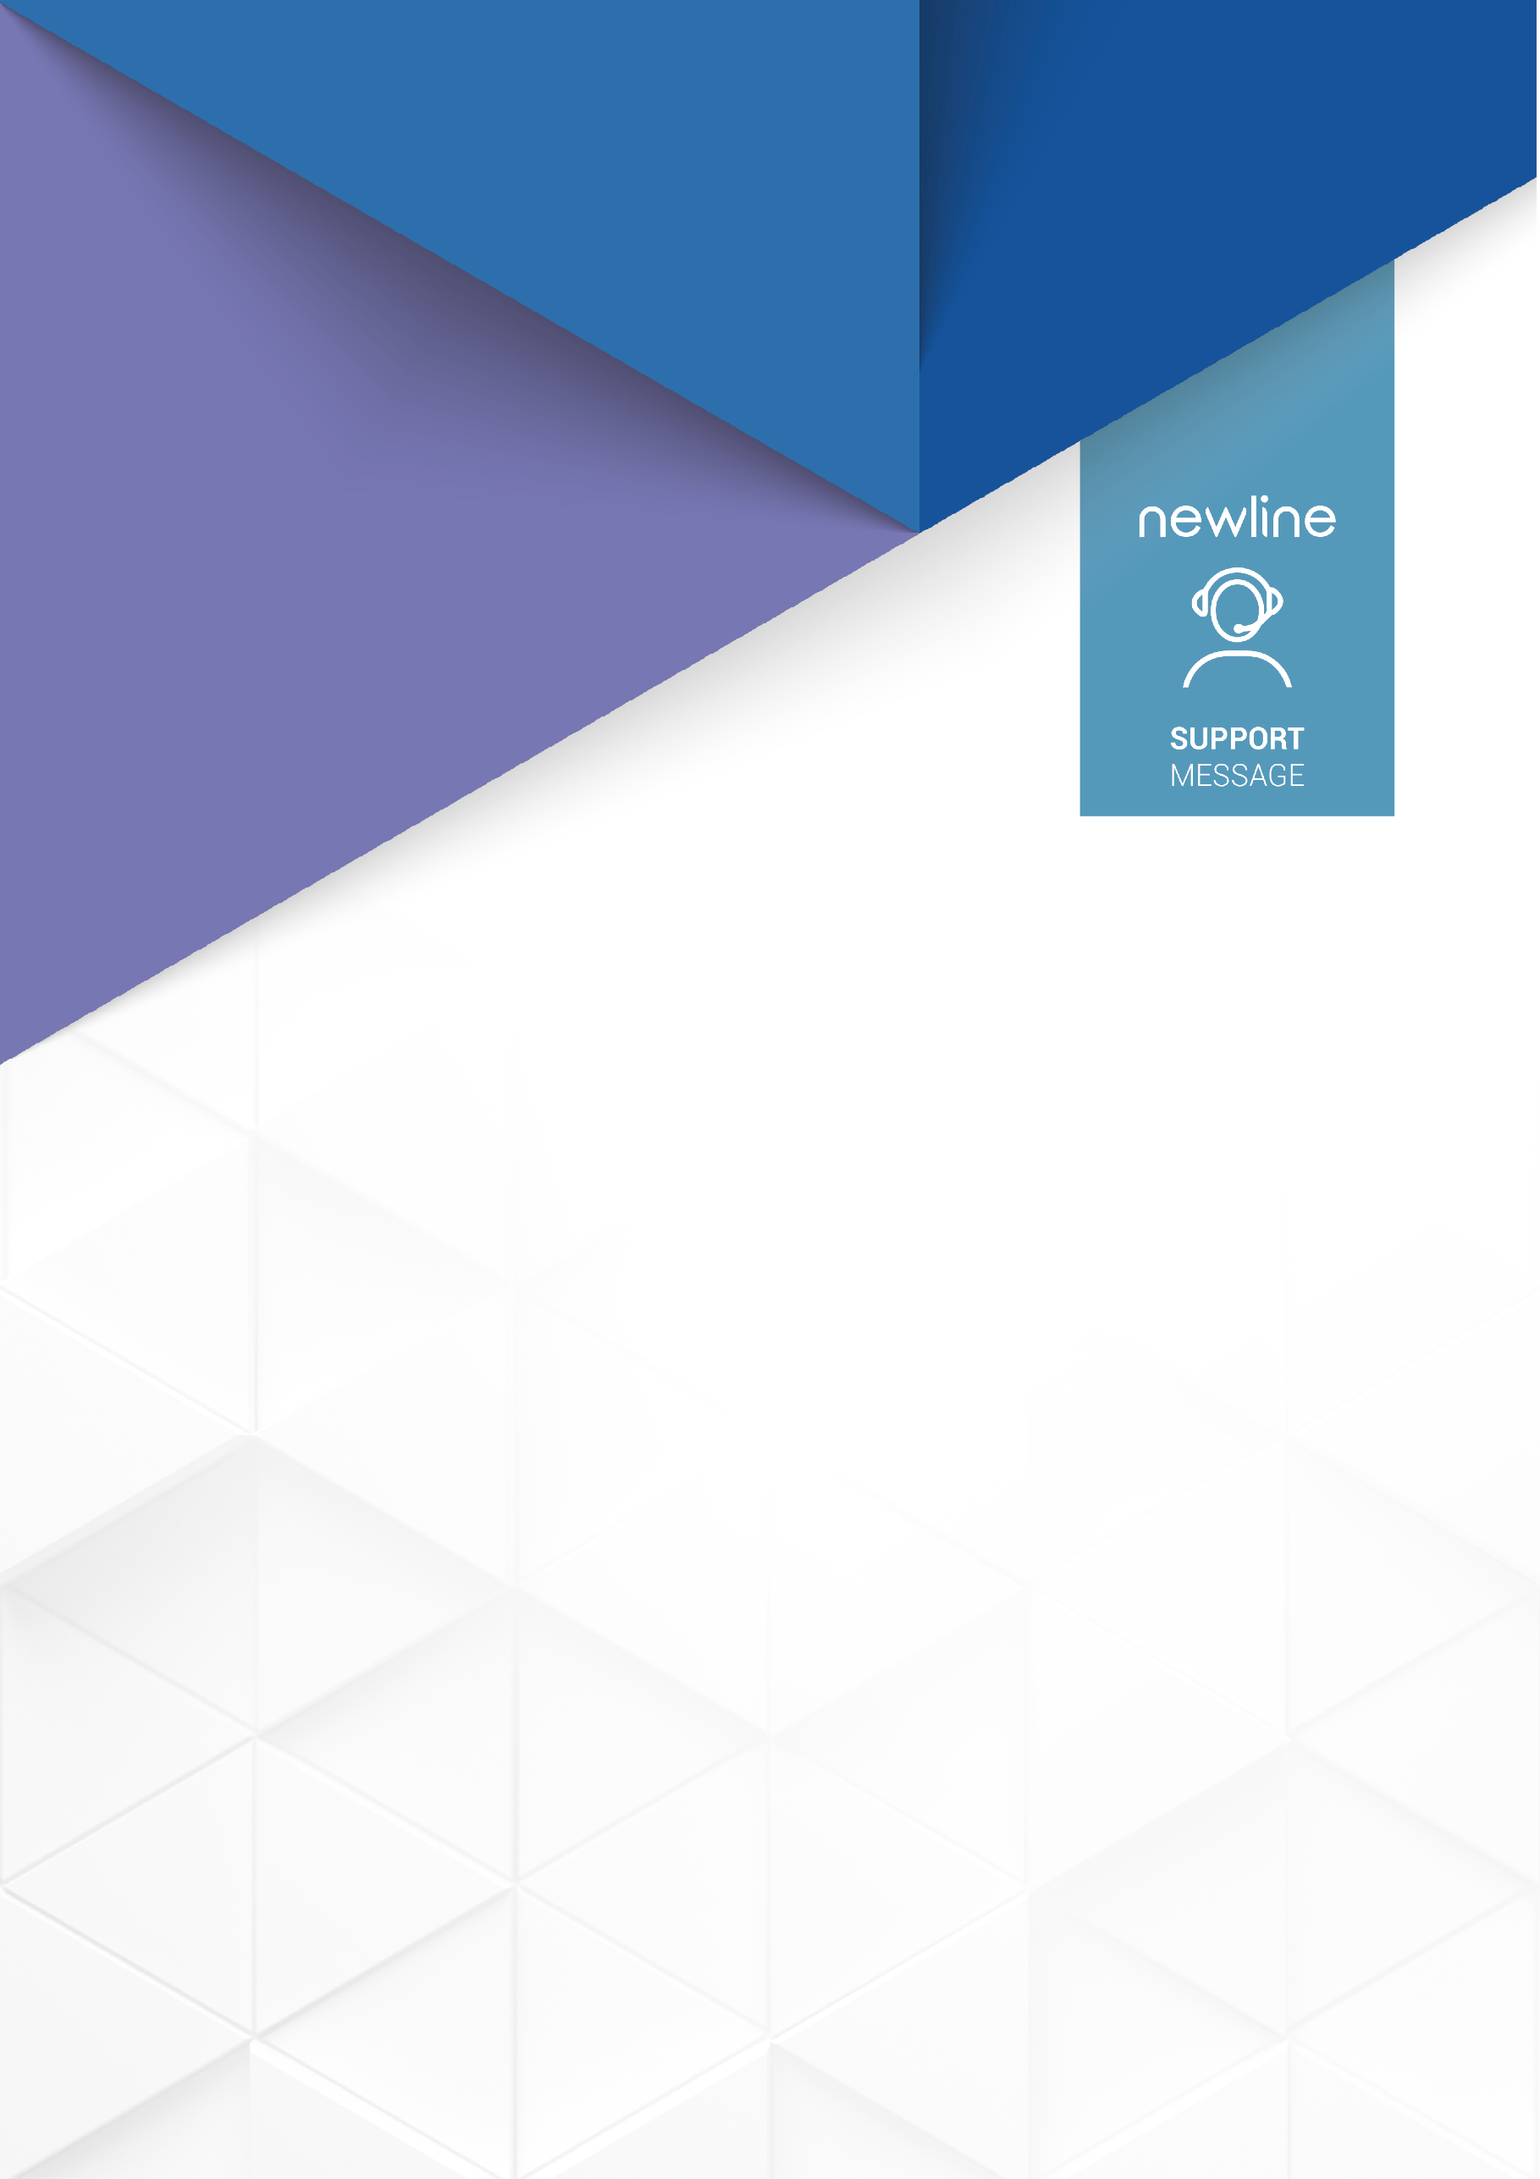

FAQ
ALL YOU NEED TO KNOW ABOUT FLEX
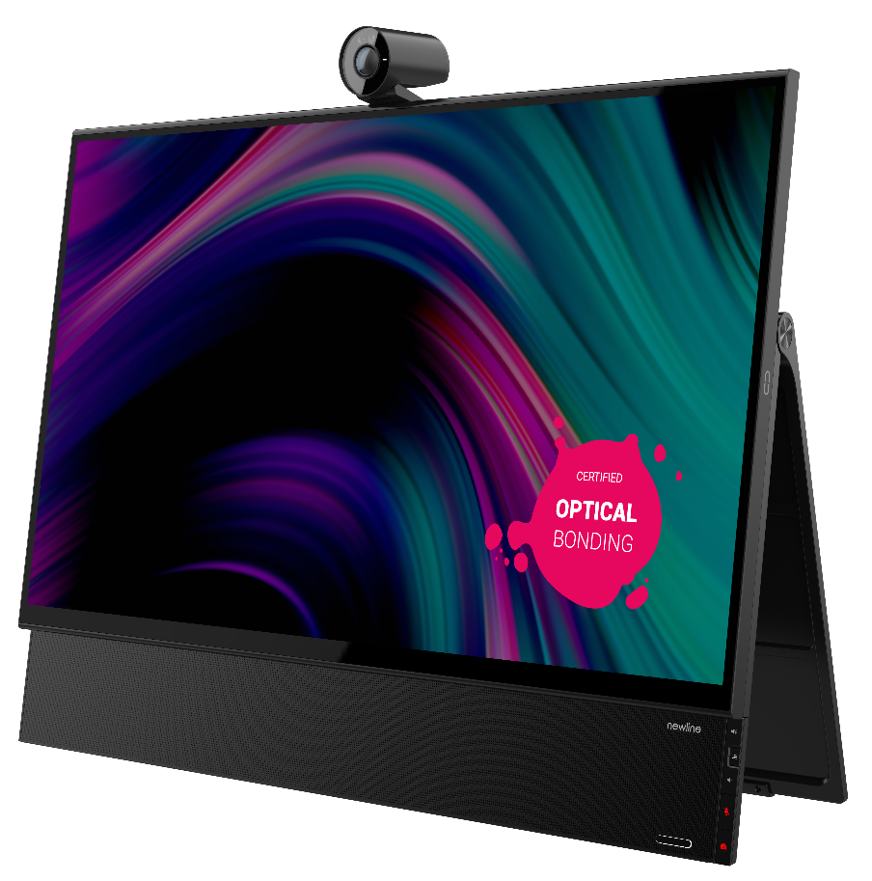

CONNECTIONS & COMPATIBILITIES

HOW DO I CONNECT MY DEVICE TO FLEX?

There are 2 ways:
- HDMI + USB B 3.0

The first way of connecting your device with FLEX is using HDMI and a USB-B 3.0 cable. The HDMI will transmit the Image and the audio. The USB-B 3.0 will transmit all touch and will also manage all the data exchanges.

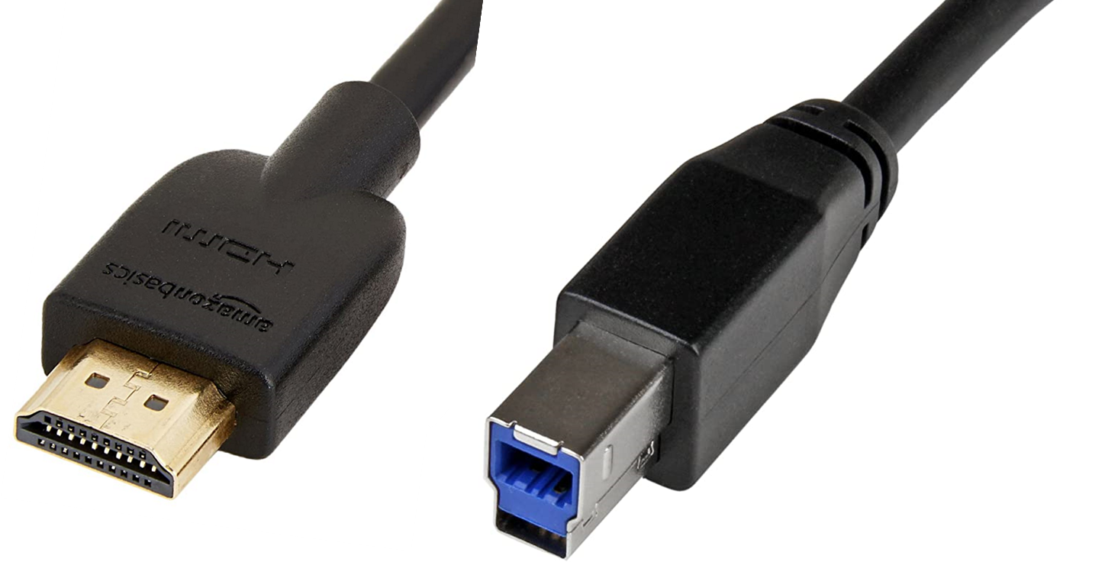

USB-B is a cable USB type A to USB type B. It is used normally for high advanced touch control like active pen systems or 4K cameras and must be 3.0 (blue connector). If we use USB B 2.0 it will not work properly. USB-B 3.0 has 9 pins to manage all information while USB B 2.0 only has 4 pins. Data transmission speed is 10 times higher in 3.0 than 2.0
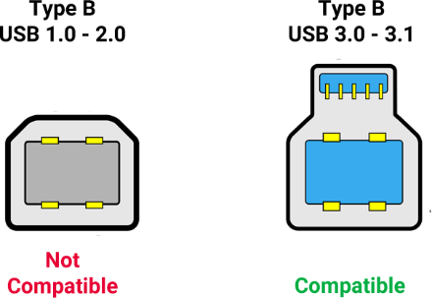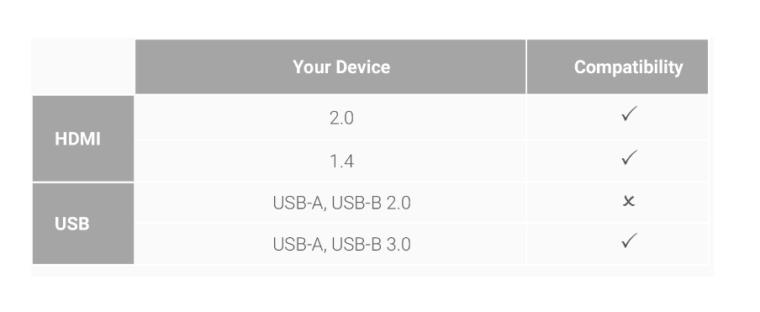
NOTE – HDMI and USB-B cables are not included in the Flex

- USB C

The second way of connecting your device using a 3.1 USB-C cable. This will allow you to provide the connected device image, audio, data transfer, touch, power, and Internet access. You will be able to use all the functions of Flex connecting with your device, with just one cable.

Not all USB-C are compatible with Flex. To know if your device is compatible you may need to check in the Following table

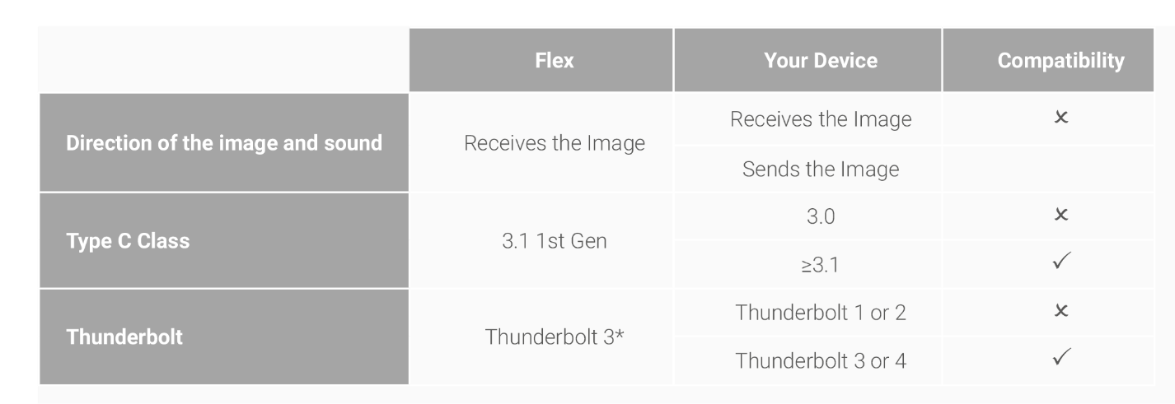
*Thunderbolt is the brand name of a hardware interface developed by Intel (in collaboration with Apple) that allows the connection of external peripherals to a computer.

If the answer is yes for all 3 of them, then it is compatible for image, sound, touch and data transfer with one single cable type C.

CAN FLEX POWER MY DEVICE?
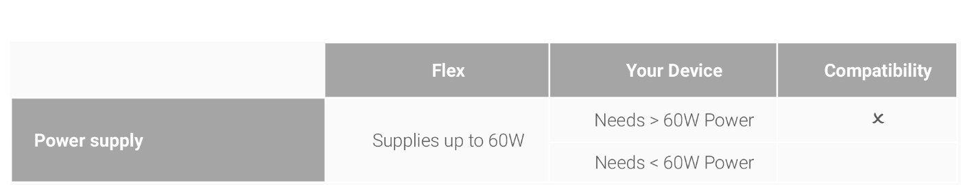
If your device accepts USB C charging and requires < 60W, then it will be compatible and charging will be possible.

IS MY FLEX COMPATIBLE WITH MAC DEVICES?

Yes, Newline Flex is fully compatible with Mac software for touch finger use. You can download the Driver here.
But what about the Flex Pen? Well, Active Pen in a Mac device only works in compatible applications and programs like AutoCAD, photoshop, etc…our developers are working on making the Flex pen compatible with these applications. It should be finished and available very soon.

IS MY FLEX COMPATIBLE WITH A SMARTPHONE?

Flex is compatible with certain Android smartphones that support output of audio and video over USB-C to external displays. It will depend on the connector and the protocol, they use. Please refer to the compatibility table of USB-C. Indeed, the experience of using a Smartphone with a Flex display will support the image and the touch of your smartphone.

CAN I HAVE WIRELESS KEYBOARD OR MOUSE?

Yes, you can, there are 2 ways:
- Adding the keyboard / mouse bluetooth dongle to the USB A connector in Flex which will be transmitted through the used connection method to your device (USB-C or HDMI+USB B).
- Or Connecting this to your device directly.

HAS FLEX WIFI OR LAN CONNECTOR?

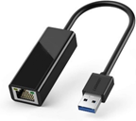
Flex is a monitor with no operating system, designed to fit into any environment. As a monitor there is no need to have internet or Wi-Fi. But of course, you can transmit Lan through it.
This is a LAN connector to USB A, if you connect This LAN connector to your network and your device to Flex, then the device will be receiving the network signal. Flex will pass this to your connected device.

WHAT IS THE SDM SLOT IN FLEX FOR?

This allows you to connect and Intel SDM-L computing devices into the display so that it can run independently of any connected computing device, the SDM device is like a small more cost-effective OPS.

Not all SDM are compatible. Intel designed this format of device back in 2016 and this is just starting to see wide scale adoption, by Manufacturers but some do not all appear to be completely following the Intel standards. We will have one compatible model soon supported by Intel and we are working on a second one.
We hope that Intel will help to correct the SDM market and make sure the standards are adopted.

CAN I HAVE LAN CONTROL OR RS232 IN FLEX?

No, Flex was not designed for this since it is a personal monitor. Controlling the device connected to FLEX will mean that you will give you some control of the device, but FLEX has no operating system that can be managed in this way.

HOW CAN I SET UP TWO SCREENS IN AN EXTENDED DESKTOP?

FLEX has no HDMI out as one of the primary sources. In case we want to extend our desktop to more than one screen there are some possibilities but all pass through the device connected to Flex.

As an example, if you get SDM then you can use the HDMI out from SDM to get your second screen, or your second FLEX, then this would be possible.

Also 2021 generation laptops have started to come with USB C 4 and thunderbolt 4 what allows the computer to control up to 2 external screens in 4k. These computers come with 2 x USB C latest generation. So, you could have a laptop + 2 Flex displays if needed, we have tested this, and it works well.

CAN I WORK WITH MORE THAN ONE DEVICE CONNECTED?

Yes, you can have up to 2 x devices connected + SDM (when available). Please be aware, that if the SDM is connected you will lose the ability to charge an external device via the USB-C Cable.

IS IT POSSIBLE TO INSTALL AN EXTERNAL VIDEO CAMERA VIA USB?

Yes, by connecting it to USB A on Flex, the laptop or SDM will therefore be able to use it. The number of peripherals connected to the system will be managed by the operating system of the device connected and the hardware specifications of this device.

IS IT POSSIBLE TO INSTALL AN EXTERNAL MICROPHONE?

Yes, via USB A or JACK connector. This will be necessary in these cases where you will be having VC close to other users, like in a call centre, where headsets with microphones will offer a better use case.

PEN

WHICH KIND OF PEN IS INCLUDED IN FLEX?

Newline Flex includes a P-CAP Active Pen which applies the MPP 1.51 protocol for touch display integration. Please, note this is not a Bluetooth Pen, it is a Pen that is already synchronized with Flex independently of the device you connect. MPP pen in Flex has 1024 pressure points for sensitive control which allows for a very precise writing and design experience.

CAN I MODIFY THE ACTIVE PEN BUTTONS?
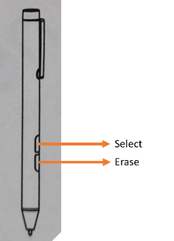
The MPP pen on Flex is synchronized with the stand-alone screen with predefined functions, so no customization is possible.

CAN I CUSTOMISE A THIRD-PARTY PEN?

If you need to have customised buttons on your pen, then it is easy to get a solution. MPP pen is a standard protocol. Most of the active pens sold in the market are compatible. They just need to buy one and synchronize with their Bluetooth device and that is all. Windows has its own function through settings to configure the active pen buttons. You can follow this path to adjust the buttons to your needs: Settings > Pen and Windows Ink > Pen shortcuts

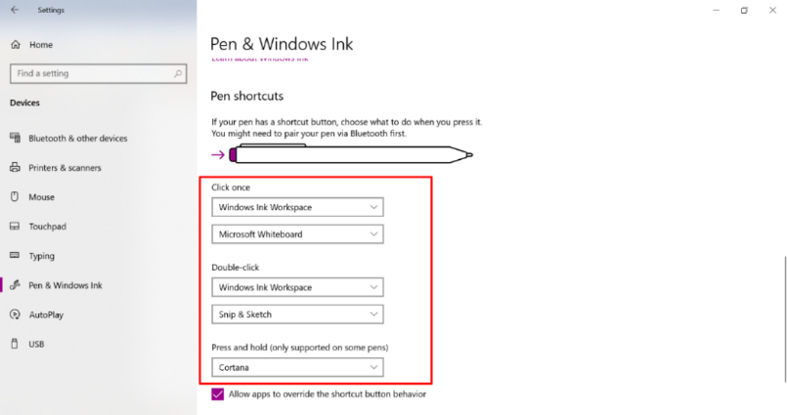
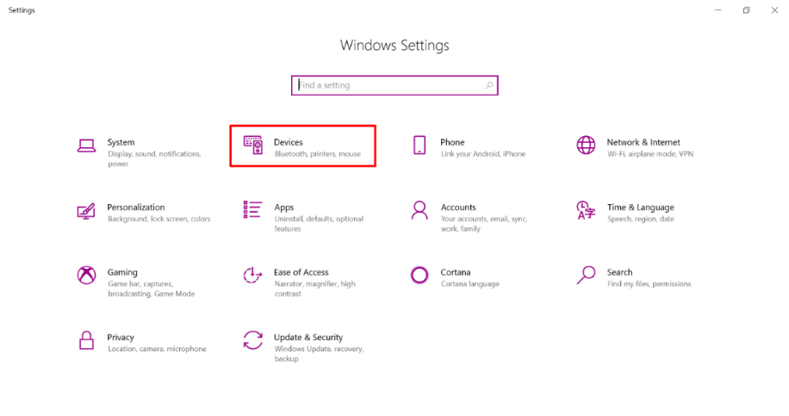
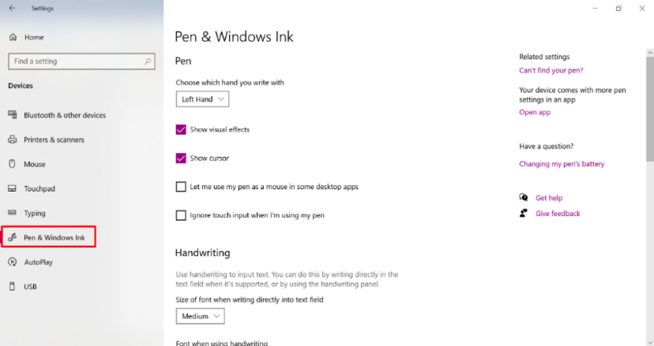

SUPPORT

WILL THE CAMERA OR PEN BE REPLACEABLE?

Yes, if through loss or damage you need a new camera or pen they can be purchased through your reseller.

IS IT POSSIBBLE TO UPDATE THE SCREEN FIRMWARE

Yes, this will be done through a USB Pen Drive, more details will be provided when we release an update.

CONTACT
If you still have any questions, please do not hesitate to contact us:
support_eu@newline-interactive.com
Technical Support Hotline: +34 91 804 31 79

